**Unit Five Lab**

Directions: Complete the assignment below and submit it by the date specified in the assignment sheet. In this lab you will connect to the Cisco’s devnet sandbox and learn the topology that we will be working with over the course of the semester. In the first part, you simply need to take a screen shot once you are in a device on the sandbox. The main deliverable for this lab is a detailed topology diagram that could be understood by any Network Engineer. It should be easy to understand the topology, IP addresses, VLANs, and interfaces. You can use commands like show IP interface brief, and materials provided by Cisco to generate your drawing. The primary outcome of this lab is for you to become intimately familiar with this network. **20 points**

1. Make sure you are logged into your email on some device. You will receive an important email from Cisco in the process that you will need to finish logging in to your lab.
2. From a browser on any device, go to: [devnetsandbox.cisco.com](https://devnetsandbox.cisco.com)
3. Log in with Cisco ID, using your Netacad credentials
4. Scroll down and click Reserve on Cisco Modeling Labs

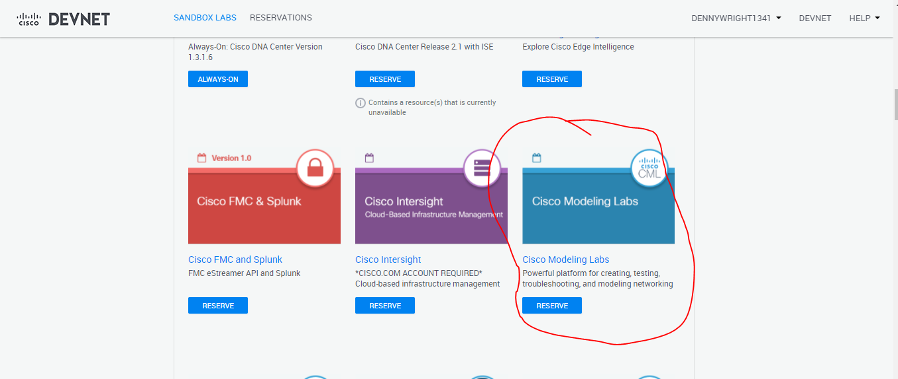

1. You can reserve up to 4 hours at a time with your ID. I recommend at least our class period.
2. You will receive an email from Cisco telling you that your lab will be set up in a few minutes. It usually takes about 10 minutes. Once it is set up, you will receive a second email. This one is important and contains critical session information.
3. Your browser will also be directed to a screen that you should review.

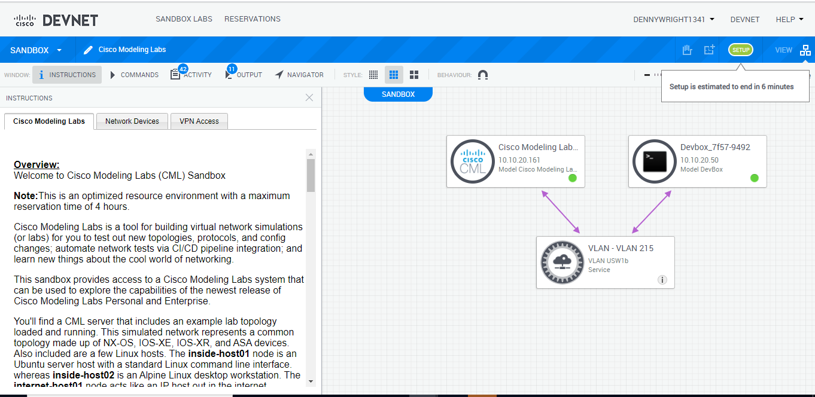

1. The tabs on the left should be reviewed carefully as they provide key information about management addresses and devices. See key information about a session for me below in red.

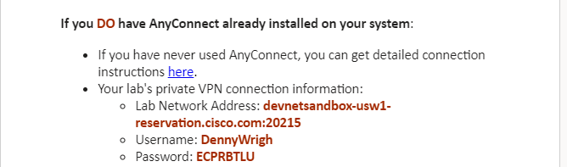

1. Once you receive your second email, you should work exclusively on your Linux station in NetLabs.
2. I recommend writing these down. You will have issues if you switch between screens.
3. From a terminal connection, type: vpn
4. You will be at a VPN configuration screen. Now you type: connect *LabNetworkAddress* where LanNetworkAddress is the url and port in your email like shown above. At the prompts, enter your username and password carefully. I find it easier to copy and paste the values to avoid error. See below for example:

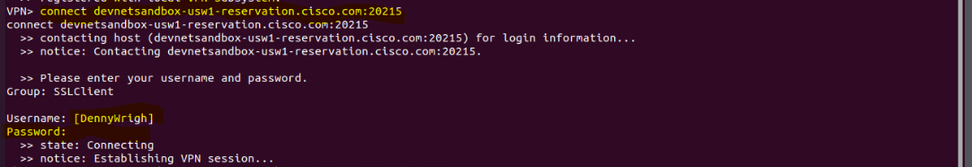

1. You can type quit to exit the VPN console. This is an AnyConnect VPN running. Note that you are still connected.
2. Go to Firefox on your Linux Station and enter the following url and credentials (also found on the Cisco Modeling Labs Tab in number 7, above:

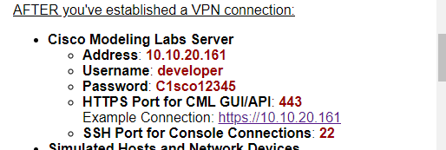

1. You will find yourself at the following page:

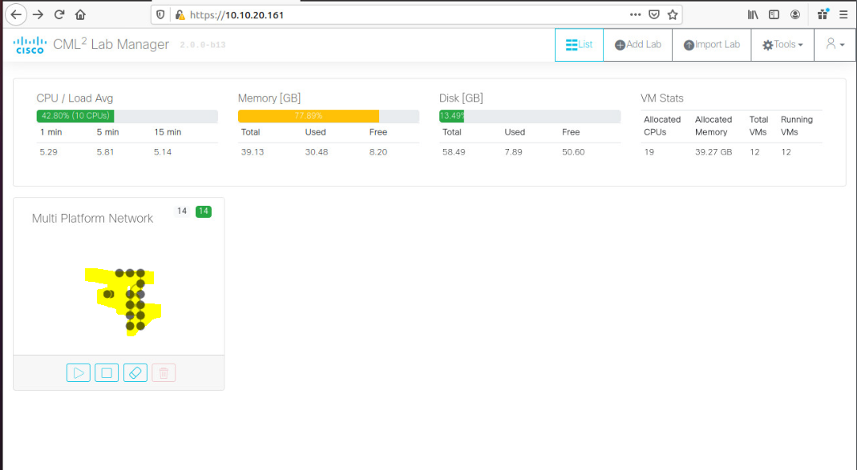

Click anywhere on the lab (highlighted above).

1. The lab appears. You can click on any device to access its console icon.

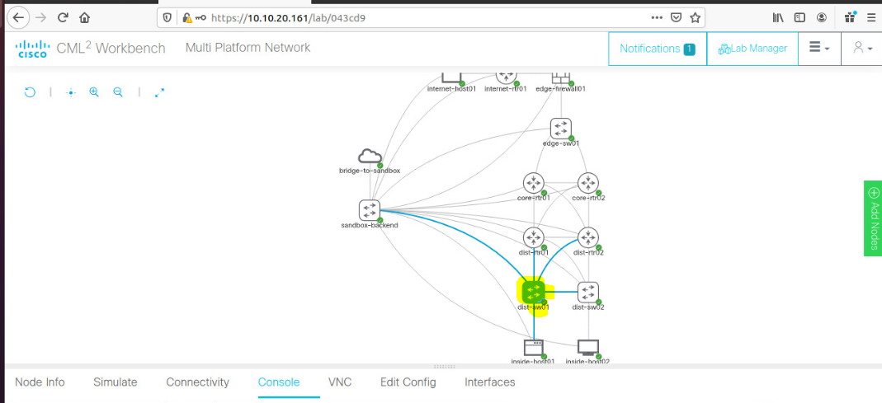

Click on a device will give you power and console icons. Choose the CLI console icon.

A console window opens below which you can size to your personal preference. The credentials for the devices are cisco/cisco, and the enable secret is also cisco.

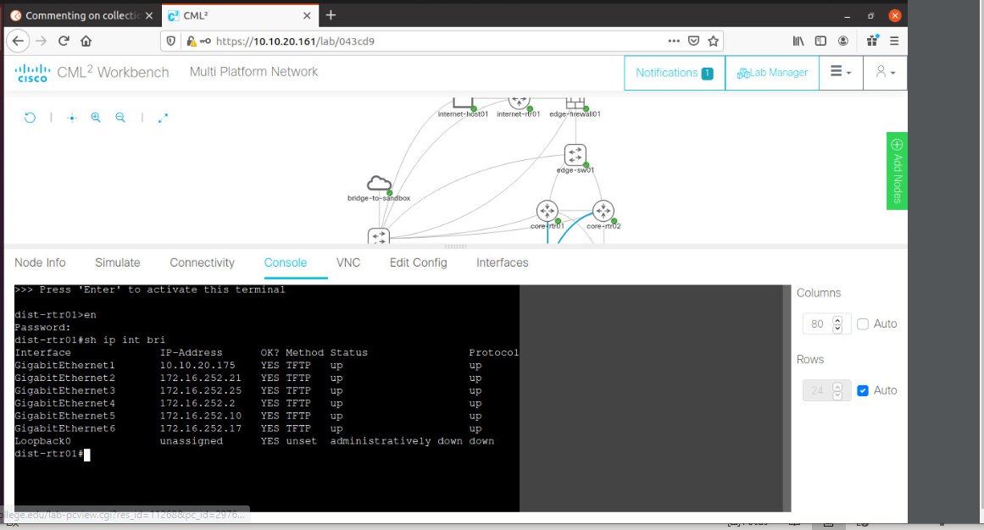

On occasion, I have noted thar the NXOS switches do not always boot up or crash to a load prompt after running for a while. If this happens, you can type the following at the Load prompt (sometimes you have to do this more than once):

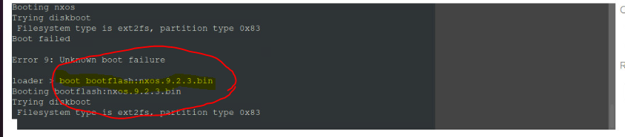

If you are done with your reservation, go the original reservation screen in Cisco Modeling Labs and end your reservation by clicking on the hand at the top.

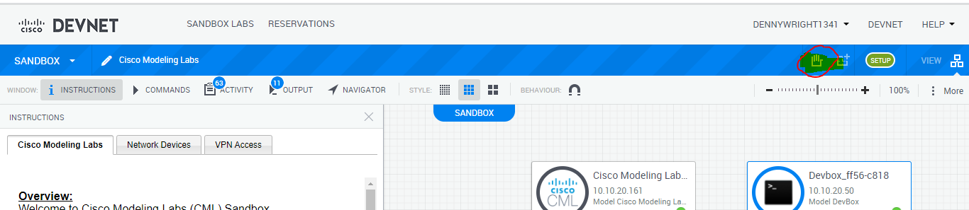

.

1. **Take a screenshot like the one above that shows a console’s output of a “show ip interface brief”, showing you are connected. Then using the lab and other supplied Cisco information, create a logical diagram as outlined above.**

